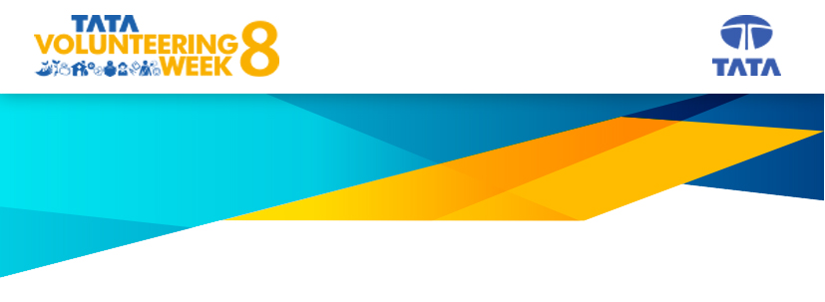
We'd like to know more about your volunteering experience. Kindly share details as
per the questions mentioned below:
1. Tell us something about yourself. (not more than 100 words)
2. What made you realise that now it’s your turn to volunteer? (not more than 100 words)
3. Which activity did you participate in? What was the unique factor of the activity that you remember the most? (not more than 150 words)
4. Share memorable moments or conversations that touched you or your fellow volunteers while volunteering. (not more than 100 words)
Please Note:
- These questions are not binding, if you feel like sharing any more details on your volunteering experience or share any additional stories that you feel are worth capturing in a blog post, please feel free to share them.
- Please do share two to three high resolution images or a video that you may have of your volunteering experience

